**Driver Station Controller Button and Joystick Definition**

Driver -Top Side

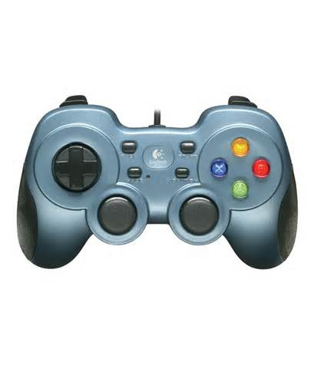

Forward/Back Joystick Y-Axis

Rotate Joystick X-Axis

Driver – Front Side

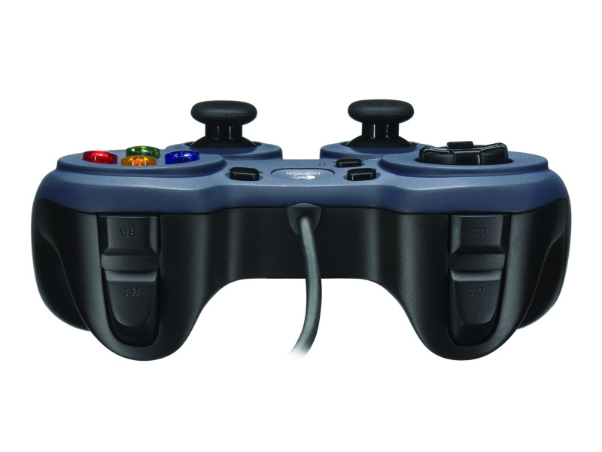

Quick Turn

Driver- Bottom Side

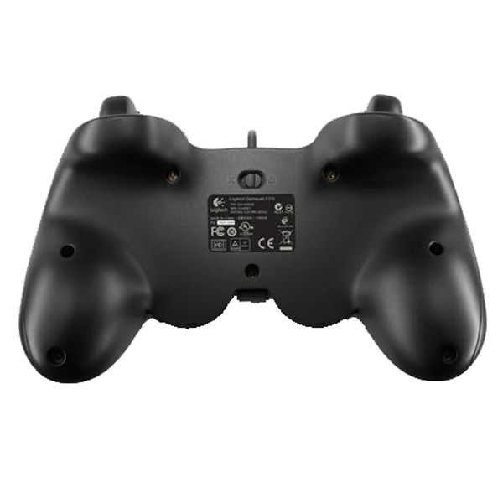

**Co-Driver Station Controller Button and Joystick Definition**

Co-Driver -Top Side



Co-Driver – Front Side



Co-Driver- Bottom Side

